
Lawrence Board of Realtors®
3838 W. SIXTH ST., LAWRENCE, KANSAS 66049 / (785) 842-1843
www.LawrenceRealtor.com

August 25, 2025

Lawrence Board of REALTORS® Releases Home Sales Figures for July 2025

Homes sales in the City of Lawrence fell by 6.3% in July compared to the prior year. Sales in July 2025 totaled 89 units, down from 95 in 2024. Through the first 7 months of 2025, 635 homes have sold in the City of Lawrence, compared to 577 in 2024, and 544 in 2023. According to Bailey Stuart, President of the Lawrence Board of REALTORS®, “While the year-to-date sales are still up 10% in Lawrence, July marks the first month of this year where homes sold dipped below last year.”
Among existing homes, 83 units sold in July, a decrease of 3.5% from 86 units that sold in 2024. The average sale price of existing homes was $387,453. This represents an increase of 7.6% from July 2024, when the average price was $360,092.
For new construction, 4 sales occurred in July, essentially unchanged from the prior year. The average sale price of new homes in July was $579,814, up 60.5% from the same period last year. The median price in July was $320,500, down 1.7% compared to $326,000 in 2024.
A total of 84 contracts for sale were written in July 2025, up from 80 in July 2024. This is an increase of 5.0%. Contracts written during the month reflect, in part, sales that will close in the near future.
The inventory of active listings in the City of Lawrence stood at 140 units at the end of July, which is down from 174 homes that were on the market at the end of July last year. At the current rate of sales, this figure represents 1.7 months' supply of homes on the market. Bailey also reported that “in 2024 from June to November we had more than a 2-month’s supply of inventory available. This year, every month has been under a 2-month’s supply, and we just closed July with 1.7 months of inventory available. Nationally, inventory levels have been at their highest level since pre-COVID. Locally we saw increases in 2023 and 2024 but have not seen this same trend in 2025. We are well below what is needed for equilibrium in the market, at 4-6 month’s supply.”
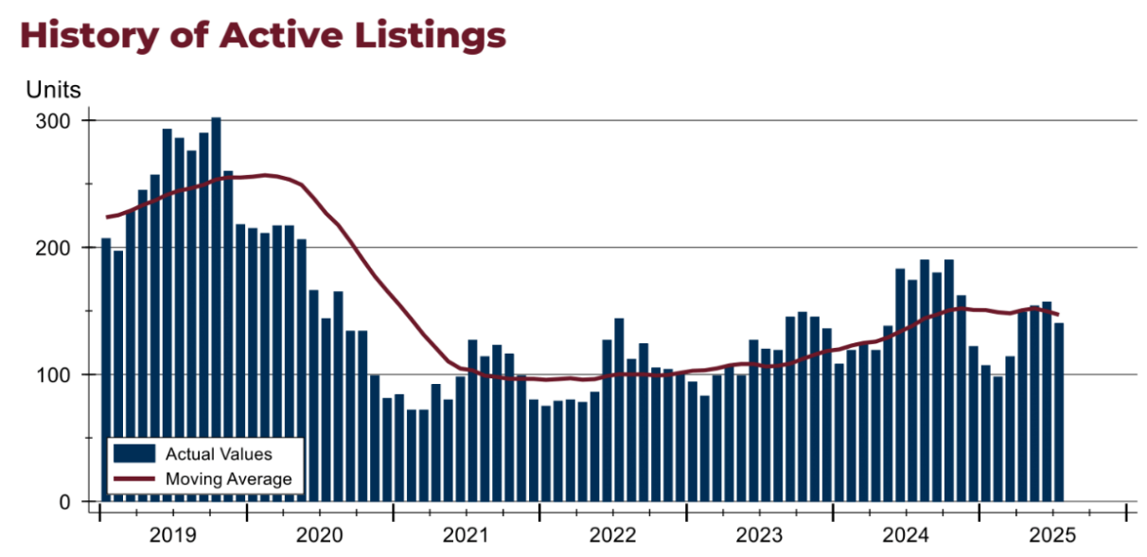
For questions and/or comments, please contact LBOR President Bailey Stuart at 785-766-7840 or BaileyStuart@askMcGrew.com.
Complete statistical summaries for Lawrence and Douglas County are available at http://www.lawrencerealtor.com/market-statistics/.


