
Lawrence Board of Realtors®
3838 W. SIXTH ST., LAWRENCE, KANSAS 66049 / (785) 842-1843

December 10, 2024

Lawrence Board of REALTORS® Releases Home Sales Figures for November 2024

Homes sales in the City of Lawrence rose by 18.5% in November compared to the prior year. Sales in November 2024 totaled 64 units, up from 54 in 2023.

Among existing homes, 61 units sold in November, an increase of 17.3% from 52 units that sold in 2023. The average sale price of existing homes was $320,353. This represents a decrease of 10.5% from the November 2023 average price of $357,941.

For new construction, 2 sales occurred in November, essentially unchanged from the prior year. The average sale price of new homes in November was $445,500, down 10.0% from the same period last year.

A total of 67 contracts for sale were written in November 2024, up from 59 in November 2023. This is an increase of 13.6%. Contracts written during the month reflect, in part, sales that will close in the near future.

The inventory of active listings in the City of Lawrence stood at 162 units at the end of November, which is up from 145 homes that were on the market at the end of November last year. At the current rate of sales, this figure represents 2.2 months' supply of homes on the market.

According to Jill Ballew, President of the Lawrence Board of REALTORS®, “Now up 3% in home sales for the year compared to 2023, we do have a more stabilized housing market, although we have quite a way to go to get back to an inventory that can support 1,300 housing units that were sold back in 2020, but we are moving in the right direction. Last month we reported on the lack of new construction inventory, and this is a big factor in our market. For 2024, new construction sales represent just 6% of the units sold. In 2020 new construction sales were 12% of units sold.”

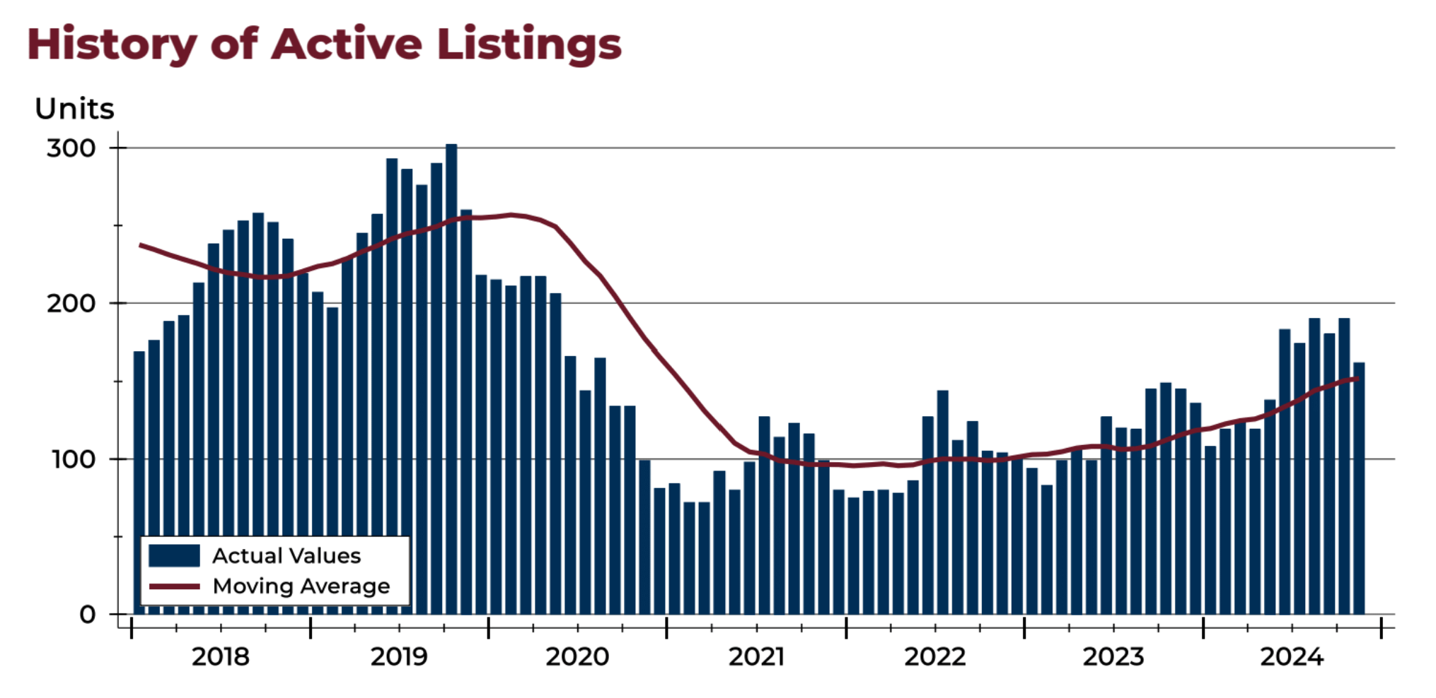

For questions and/or comments, please contact LBOR President Jill Ballew at 785-760-6632 or jillballew@stephensre.com.

Complete statistical summaries for Lawrence and Douglas County are available at http://www.lawrencerealtor.com/market-statistics/.


